About Ministers…
Preach (teach) the word; be prepared in season and out of season; correct, rebuke, and encourage—with great patience and careful instruction. — II Timothy 4:2
Ministers are men who feel called by God to use their gifts in the local congregation of the church. They work closely with the church’s Elders and Deacons to provide the leadership necessary for the growth and maturing of God’s people. Ministers fulfill their roles in the pulpit, in the educational program of the church, in the activities of the youth, in the participation of activities that affect the surrounding community, and in other vital work. Their ministry is to honestly and consistently point us to God and help us learn and serve along the way.

Webb Chapel Ministers

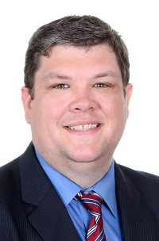Paul Cartwright
Pulpit Minister
Paul Cartwright came to Webb Chapel in August 2016 following eight years working with the youth and families of the congregation in Pearland, Texas, in the Houston area. Paul had grown up in Texas City and League City, Texas. He and his wife April met at Harding University and were married October 21, 2006. Paul and April welcomed their daughter Emma in September of 2010.
Paul earned a Bachelor of Arts degree in Bible with an emphasis in Youth and Family Ministry from Harding University.During the twelve years following graduation, Paul and April worked in ministries in Arkansas, California, and Texas, finally returning to Texas in 2008. In addition to preaching, Paul has experience which includes worship planning, song leading, special program planning, visitation, Bible studies, fellowships, hospital visitation, as well as work in other areas.
To see a list of his sermons, visit our audio archive page, Listen Now or our video sermon archive, Watch Now.

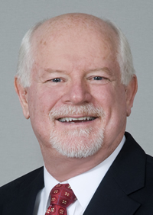Bert Alexander, DMin
Associate Minister
Bert Alexander came to Webb Chapel in June 2000 as Involvement and Education Minister. He had served as Associate Minister at an area congregation previously. Bert and his wife, Cheryl, met at Freed Hardeman University and were married May 29, 1976. They have lived in the Dallas area since 1977. Bert and Cheryl are the parents of two daughters, Allison & husband Ryan Kirksey and Ashley & husband Tim Miller. They have two granddaughters and two grandsons.
Bert received his Bachelor of Arts in Communications from Freed Hardeman while Cheryl earned a Bachelor of Science in Education. He also earned his Master of Science in Bible from Abilene Christian University, his Master of Divinity from Lipscomb University, and his Doctor of Ministry from ACU.
Bert is involved in community-outreach activities, pastoral counseling, adult education, and membership involvement. Bert serves as chaplain for the Farmers Branch Fire Department. He's occasionally called upon to preach. To see a list of his sermons, visit our Guest Speaker page.

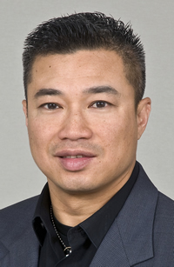Hai Cao
Youth Minister
Hai came to Webb Chapel in 2003 following eight years of work as Youth Minister in two Ft. Worth congregations. He was born in Viet Nam, and his family came to the United States in 1975. Hai earned a BA degree in Political Science at the University of Texas at Arlington. After working for a law firm for three years, Hai entered the Brown Trail School of Preaching and completed that program of study.
Hai met his wife Valerie Roncancio at Webb Chapel where both he and her father are ministers. They have two daughters, Mailee and Tamiah, and two sons, Daniel & Joshua.
Hai describes his ministry with youth as a Discipleship Ministry. He is a tireless worker, providing many avenues for young people at Webb Chapel to grow and develop and reach out to those who are troubled. Hai occasionally is called upon to preach. To see a list of his sermons, visit our Guest Speaker page.

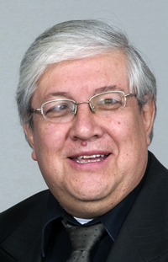Henry Roncancio
Cross-Cultural Minister
Henry Roncancio came to Webb Chapel in March 2001 as Cross-Cultural Minister. He was born in Bogota, Columbia, and now is a U.S. citizen. Henry graduated from the Sunset School of Preaching in 1977 and returned to Bogota where he worked as a missionary for nine years. Henry and Consuelo Martinez were married April 1, 1981. They moved to the United States in 1986 with their two young daughters, and Henry spent the next fifteen years as minister of Western Heights Iglesia de Cristo in Dallas.
Henry has several years of experience in teaching ESL, both in Columbia and in the United States. In 1994, Henry earned a Bachelor of Arts degree in Sociology from The University of Texas at Dallas, graduating Summa Cum Laude. Henry and Consuelo are the parents of Valerie and husband Hai Cao, Raquel and husband Raul Alvarez, and Henry Dan. They have three grandsons, Daniel, Diego, and Joshua and two granddaughters, Mailee and Tamiah.
Henry is active in mission work in Mexico, Latin America, and South America. Henry’s vision is to use today’s technological advances to teach globally. He has assembled a team of members who share his vision and who are working to share God’s Word throughout the world via Internet Radio. In addition to preaching for the Spanish-language services, Henry occasionally is called upon to preach during our English-language services. To see a list of his English sermons, visit our Guest Speaker page.

